

**PROJECT:** CAR RENTAL SYSTEM

**GROUP NO.:** 04 **BATCH:** T1.2010.E0

1. **SYSTEM REQUIREMENTS:**

|  |  |  |
| --- | --- | --- |
| **No.** | **Item** | **Description** |
| 1 | Operating System | Windows 7 or higher |
| 2 | Hardware | CPU Cores or better with 2 Gigabytes of RAM or better |
| 3 | Web Browser | Latest version of Chrome, Firefox, |
| 4 | Fonts | Unicode Fonts |
| 5 | Software | XAMPP, composer, working internet connection. (*Optional: Visual Studio Code for source code edit*) |

1. **INSTALLATION GUIDE**
2. **XAMPP:** Download and install latest version of **XAMPP** from:

<https://www.apachefriends.org/download.html>

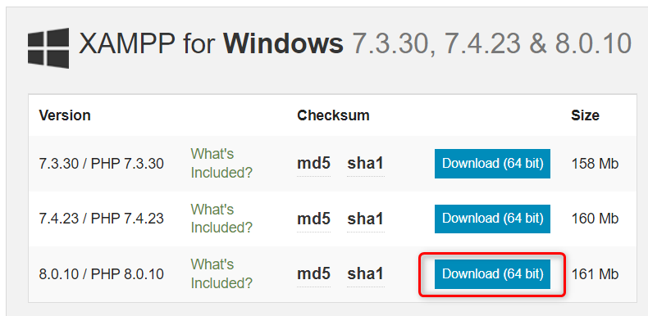

After installation, open XAMPP and start **Apache** and **MySQL**. 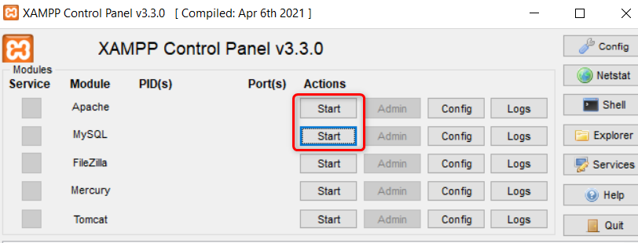

Then click on **Config.** and choose **Apache (httpd.conf)**.

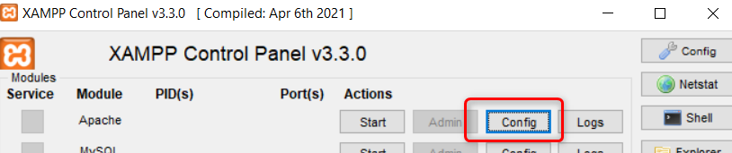

Change port from 80 to 8080

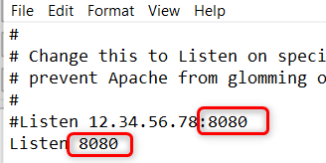

1. **My SQL:** Create database on MySQL.

Access: <http://localhost:8080/phpmyadmin/> and click **Import**.

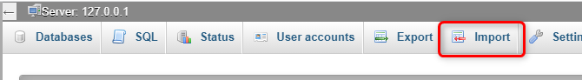

Click on Choose File and browse for the **.sql** file in the **Database Script** folder to import. After that the database **deluxerentalsdb** will be created. However user can create their own database with different name to use.

1. **Composer:** Download and install latest version of **Composer** from:

http://getcomposer.org/download

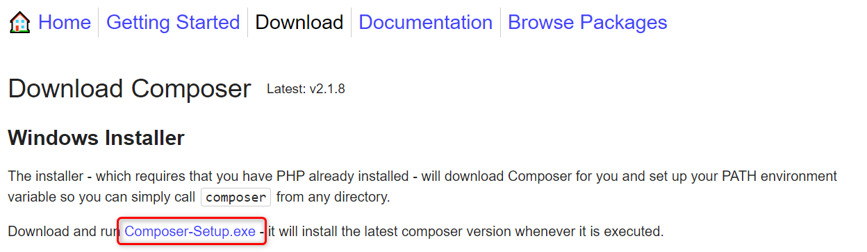

1. **Extract the program:** Extract the **.zip** file in the **Source code** folder to the folder **C:\xampp\htdocs** (or other folder on which the user has configured PHP project to run). The extracted folder name is **DeluxeRentals** as default, but the user can change this name to anything.
2. **Configure the program:**

Open the .env file from the DeluxeRentals folder with code editing programs such as **Visual Studio Code** and change the database name to **deluxerentalsdb** (or the name of the database created by user).

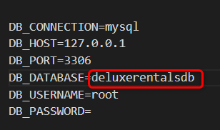

Open **Windows Powershell** and go to the extracted folder. (e.g: Run command “cd C:\xampp\htdocs\DeluxeRentals”)

After directing to the **DeluxeRentals** folder, run the following commands in exact sequence:

* copy .env.example .env
* composer install
* php artisan key:generate
* php artisan migrate
* php artisan db:seed

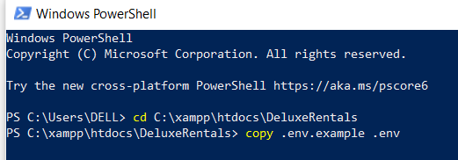

1. **Test run the program:** Open the following link:

<http://localhost:8080/DeluxeRentals/public/homepage>

If you see the homepage as below, you have successfully installed the “**CAR RENTAL SYSTEM**”. **Congratulation!**

